Howard Pflanzer, Playwright
Kathleen Potts, Playwright
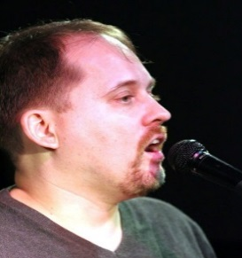
L. R. Laverde-Hansen, Playwright
Lionelle Hamanaka, Playwright
Nathaniel Blake Johnson, Playwright
Crossways Theatre
Crossways Theatre is a new community theatre,, an intersection for and devoted to all diverse peoples of New York City. Crossways develops playwrights and actors who reflect our multiracial, multiethnic experiences: whether comic, farcical or realistic, plays that cover struggles for women’s liberation, on-the-job, veteran, trauma or the challenges of life, we serve an audience from teens to seniors.

PRESENTS: A FALL FESTIVAL
FACING THE FUTURE FRIDAY NOVEMBER 4, 2022
DRAMATISTS GUILD FOUNDATION
520 8th AVENUE, STE. 2401
TIME: 6-9 PM
Donations accepted for CROSSWAYS THEATRE via Square or any other way
Facebook: Crosswaystheatre.org Email: Crosswaystheatre@gmail.com
Crossways Theatre is a 501©3

PLAYS:
CLARION CALL by Nathaniel Blake Johnson
THE JUDGEMENT by Howard Pflanzer
Scenes from THE MOUNTAIN AND THE VALLEY
By Lionelle Hamanaka
A POETIC SEGMENT by Lyonel Laverde Hansen, Ronald Haynie, Pauline and Alyssa D’Amico.

*These actors appear courtesy of Actors Equity

FEATURED ACTORS:
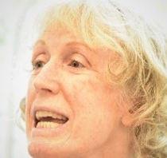
*BETH GRIFFITH is a well known NYC actress and just returned from a tour in from Europe. She is an opera star
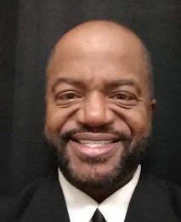
RONALD HAYNIE was "Jeffrey Black" in the Spellbound Repertory Chillerfest at The American Theatre of Actors.

*KATHERINE ALT KEENER has been in regional, TV, film, off-off Broadway shows in Chekhov, Shakespeare and Tennessee Williams.

*ALYSON LINEFSKY has graced NY and NJ stages in many contemporary plays and films, and trained in the Meisner and Adler methods.

*ARTHUR LUNDQUIST was in contemporary and classical works, Chekhov to Shakespeare, musicals like Annie and TV and films, well trained in England.

*CLINTON POWELL has acted in many Shakespearean plays, as a principal in Indie films, and studied the Grotowski method.

